Project Design Phase-II
Data Flow Diagram & User Stories

Date | 25-12-2025
Team ID
Project Name | Shopez – MERN E-Commerce Platform
Maximum Marks | 4 Marks

1. Data Flow Diagram (DFD)

Objective
The primary objective of the Shopez – MERN E-Commerce Platform is to design and develop a scalable, secure, and user-friendly online shopping system that simplifies the process of product browsing, ordering, and order management for both customers and administrators. The project aims to provide a real-world simulation of an e-commerce platform using modern web technologies, thereby enhancing practical understanding of full-stack application development.
This system is designed to overcome common challenges faced by users on existing e-commerce platforms, such as complex user interfaces, unclear checkout workflows, lack of transparent order tracking, and inefficient administrative control. Shopez focuses on delivering a clean and intuitive user experience that allows customers to easily search for products, add items to a shopping cart, place orders, and complete payments through a dummy payment simulation, ensuring a smooth end-to-end purchasing flow.

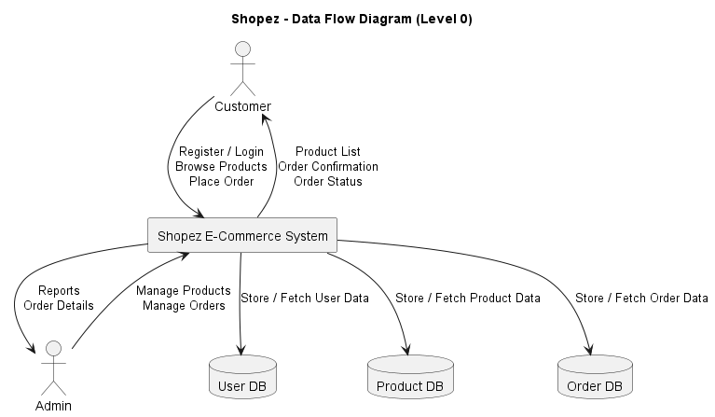

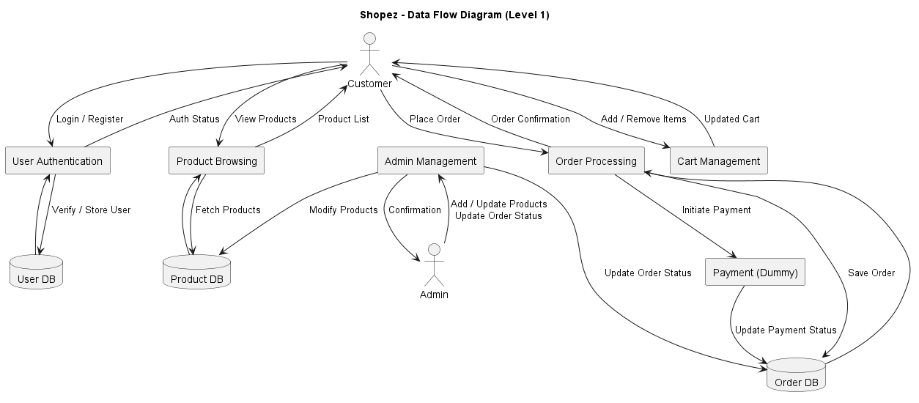

User Stories
User Stories – Customer
Story ID | User Story
US-1 | As a customer, I want to register and log in securely so that I can access my account.
US-2 | As a customer, I want to browse products by category so that I can find items easily.
US-3 | As a customer, I want to add products to my cart so that I can purchase multiple items.
US-4 | As a customer, I want to place an order and make payment so that I can complete my purchase.
US-5 | As a customer, I want to track my order status so that I know when my order will be delivered.

User Stories – Admin
Story ID | User Story
US-6 | As an admin, I want to add new products so that they are available for purchase.
US-7 | As an admin, I want to update or delete products so that inventory stays accurate.
US-8 | As an admin, I want to view all orders so that I can manage deliveries.
US-9 | As an admin, I want to update order status so that customers are informed.

